









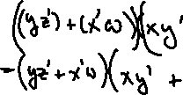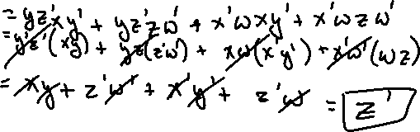



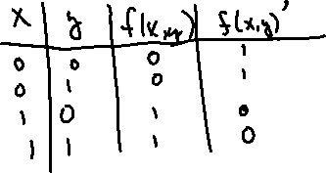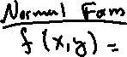







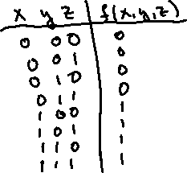



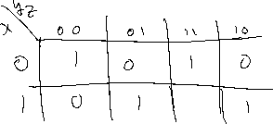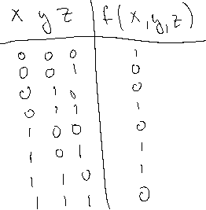

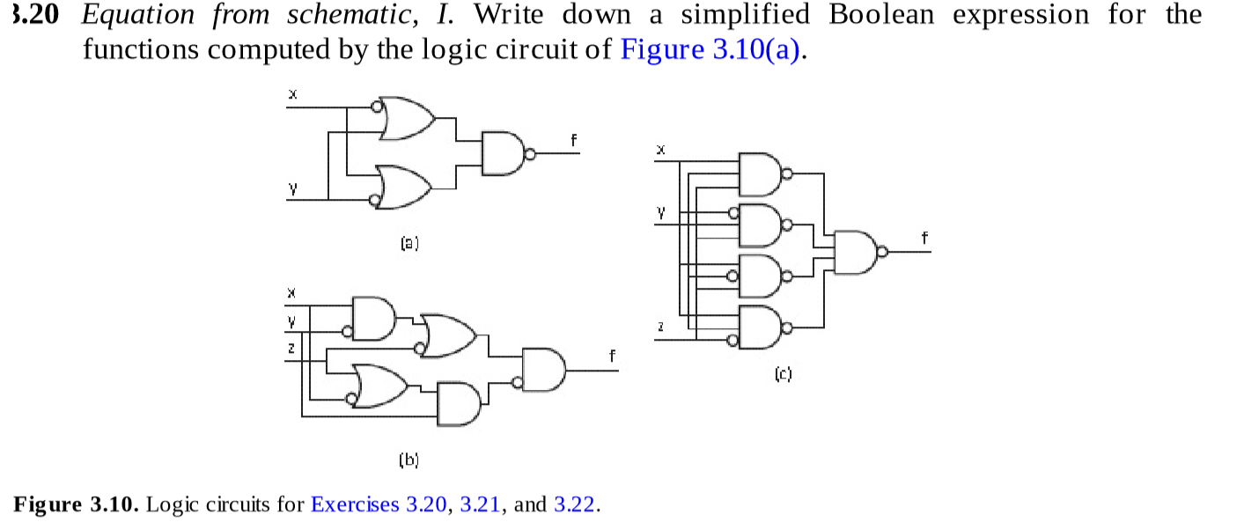

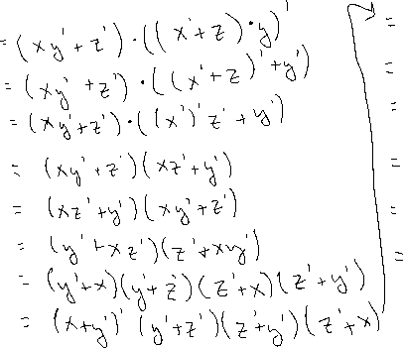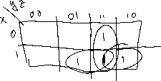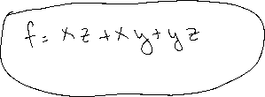



|  |  |  |  |  |  |  |  |  |  |  |
| --- | --- | --- | --- | --- | --- | --- | --- | --- | --- | --- |
|  | X | Y | Z | X’ | Y’ | Z’ | X’YZ’ | X’Y’Z’ | XY’Z’ | F |
| 0 | 0 | 0 | 0 | 1 | 1 | 1 | 0 | 1 | 0 | 1 |
| 1 | 0 | 0 | 1 | 1 | 1 | 0 | 0 | 0 | 0 | 0 |
| 2 | 0 | 1 | 0 | 1 | 0 | 1 | 1 | 0 | 0 | 1 |
| 3 | 0 | 1 | 1 | 1 | 0 | 0 | 0 | 0 | 0 | 0 |
| 4 | 1 | 0 | 0 | 0 | 1 | 1 | 0 | 0 | 1 | 1 |
| 5 | 1 | 0 | 1 | 0 | 1 | 0 | 0 | 0 | 0 | 0 |
| 6 | 1 | 1 | 0 | 0 | 0 | 1 | 0 | 0 | 0 | 0 |
| 7 | 1 | 1 | 1 | 0 | 0 | 0 | 0 | 0 | 0 | 0 |

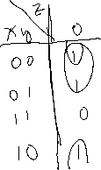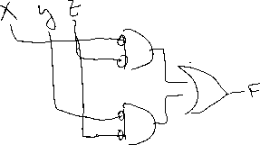



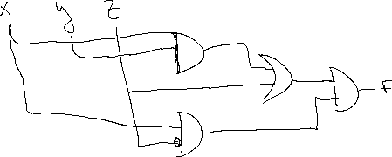

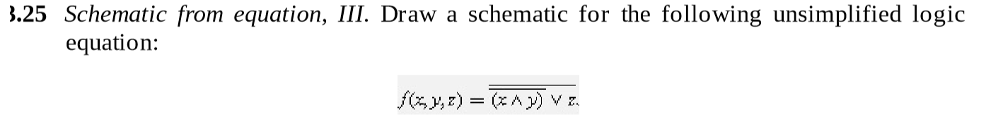



|  |  |  |  |  |  |  |  |
| --- | --- | --- | --- | --- | --- | --- | --- |
|  | X | Y | Z | XY | X’Y’ | (XY)’ + Z | F |
| 0 | 0 | 0 | 0 | 0 | 1 | 1 | 0 |
| 1 | 0 | 0 | 1 | 0 | 1 | 1 | 0 |
| 2 | 0 | 1 | 0 | 0 | 1 | 1 | 0 |
| 3 | 0 | 1 | 1 | 0 | 1 | 1 | 0 |
| 4 | 1 | 0 | 0 | 0 | 1 | 1 | 0 |
| 5 | 1 | 0 | 1 | 0 | 1 | 1 | 0 |
| 6 | 1 | 1 | 0 | 1 | 0 | 0 | 1 |
| 7 | 1 | 1 | 1 | 1 | 0 | 1 | 0 |

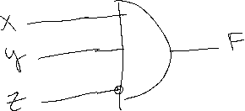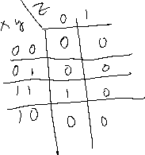



|  |  |  |  |
| --- | --- | --- | --- |
| x | y | z | f |
| 0 | 0 | 0 | 0 |
| 0 | 0 | 1 | 1 |
| 0 | 1 | 0 | 1 |
| 0 | 1 | 1 | 1 |
| 1 | 0 | 0 | 1 |
| 1 | 0 | 1 | 1 |
| 1 | 1 | 0 | 1 |
| 1 | 1 | 1 | 0 |

F = x’y’z + x’yz’ + x’yz + xy’z’ + xy’z + xyz’

